**Kathmandu University**

**Department of Computer Science and Engineering**

**Dhulikhel, Kavre**



**Lab Report Four**

**[COMP342]  
  
(For partial fulfillment of 3rd Year/1st Semester in Computer Science)**

**Submitted by:**

Yugesh Upadhyaya Luitel (38)

**Submitted to:**

Mr. Dhiraj Shrestha

Department of Computer Science and Engineering

**Submission Date**: December 14, 2022

Table of Contents

Chapter 1: Circle and Ellipse Drawing Algorithm 1

1.1 Introduction 1

1.2 Additional Tools 1

Chapter 2: Mid-Point Circle Drawing Algorithm 3

2.1 Algorithm 3

2.2 Source Code 4

2.3 Outputs 7

Chapter 3: Mid-Point Ellipse Drawing Algorithm 8

3.1 Algorithm 8

3.2 Source Code 10

3.3 Outputs 13

Chapter 5: Conclusion 15

# Chapter 1: Two Dimensional Transformation

## 1.1 Introduction

A two-dimensional transformation is a function or a mapping, which when applied to a two-dimensional point (or shapes, constructed using points) will transform or map it into another two-dimensional point (or shape, made out of the mapped points). Essentially, Two Dimensional Transformation maps a set of Original Points O of a 2D Space into a set of Transformed Points T into the same 2D space.

There are various transformations that can be obtained in two-dimensional space, and through this particular lab work we aim to explore these transformations and their effects to a two-dimensional triangle of our choice. Amongst the various transformations, we will be looking at:

* Translation
* Rotation
* Scaling
* Reflection
* Shearing

## 1.2 Additional Tools

The Programming Language, Graphics Library and Tools used for Generation Algorithms are as follows:

**Programming Language:** Python 3.10

**Graphics Library:** PyOpenGL 3.1.6

**Window Renderer:** GLUT

**Helper Library:** ctypes,numpy

Helper Function transformationFunction to generate transformation matrix.

BuildData() to make a triangle

The data points generated using the Mid-Point Algorithm are discrete integer values. However, the Modern OpenGL approach requires the coordinates to be in Normalized form from (-1,-1) to (1, 1). So, for conversion of the generated datasets to normalized form, I have created a helper function named tonormalized. It takes in the generated datasets and the screen resolution for which the data has been generated as inputs and returns the normalized coordinates needed for our Graphics Library as its output.

**Code Snippet for tonormalized**

def tonormalized(coordinates, resolution):

for coordinate in (coordinates):

coordinate[0] = coordinate[0] * 2 / (resolution[0])

coordinate[1] = coordinate[1] * 2 / (resolution[1])

return np.array(coordinates, dtype = np.float32)

Moreover, a Circle is Symmetric about the 8 Octants and Ellipse is Symmetric about the 4 Quadrants. The Mid-Point Algorithm utilizes this symmetricity property of these shapes to minimize the computation required to generate our data points. Hence, the initial data points generated using the Mid-Point Algorithm are used to generate 7 other data points for a Circle and 3 other data Points for an Ellipse.

So, I have created helper functions for Circle as well as Ellipse to assist in the generation of these Symmetry points.

**Code Snippet for Circle Symmetry Helper:**

def generateOtherPoints(data, center):

circlePoints = []

for point in data:

circlePoints.append([point[0] + center[0], point[1] + center[1], point[2]])

circlePoints.append([-point[0] + center[0], point[1] + center[1], point[2]])

circlePoints.append([point[0] + center[0], -point[1] + center[1], point[2]])

circlePoints.append([-point[0] + center[0], -point[1] + center[1], point[2]])

circlePoints.append([point[1] + center[0], point[0] + center[1], point[2]])

circlePoints.append([-point[1] + center[0], point[0] + center[1], point[2]])

circlePoints.append([point[1] + center[0], -point[0] + center[1], point[2]])

circlePoints.append([-point[1] + center[0], -point[0] + center[1], point[2]])

return circlePoints

**Code Snippet for Circle Symmetry Helper**

def generateOtherPoints(data, center):

ellipsePoints = []

for point in data:

ellipsePoints.append([point[0] + center[0], point[1] + center[1], point[2]])

ellipsePoints.append([-point[0] + center[0], point[1] + center[1], point[2]])

ellipsePoints.append([point[0] + center[0], -point[1] + center[1], point[2]])

ellipsePoints.append([-point[0] + center[0], -point[1] + center[1], point[2]])

return ellipsePoints

Chapter 2: General 2D Transformation

## 2.1 Algorithm

The algorithm used to generate the data points based on the Center and Radius of a circle through the use of Mid-Point Circle Drawing Algorithm is as follows:

1. Take Center (x, y) and Radius r of the Circle as inputs.
2. Check r > 0 : if True Continue with Step 3, else Abort
3. Set xValue to 0 and yValue to r.
4. Set Initial Decision Parameter as: Pk = 1 – r.
5. Store (xValue, yValue)
6. Perform the following test:
   1. If Pk < 0 : update Pk = pk + 2 * xValue + 3
   2. Else : update Pk = Pk * (xValue - yValue) + 5 and set yValue = yValue – 1
7. Update xValue = xValue + 1
8. Repeat Step 5 onwards until xValue > yValue

**Note:** While storing xValue and yValue, other 7 Symmetric Data Points are calculated and stored as well. Moreover, the Center (xc, yc) is added to the respective coordinates of these stored values. So, the 7 Symmetric Points for (xValue, yValue) are:

**(-xValue, yValue), (xValue, -yValue), (-xValue, -yValue), (yValue, xValue), (-yValue, xValue), (yValue, -xValue), (-yValue, -xValue)**

and, the stored data values are:

**(xc + xValue, yc + yValue), (xc - xValue, yc + yValue),**

**(xc + xValue, yc - yValue), (xc - xValue, yc - yValue),**

**(xc + yValue, yc + xValue), (xc - yValue, yc + xValue),**

**(xc + yValue, yc - xValue), (xc - yValue, yc - xValue)**

## 2.2 Source Code

import os

import sys

import ctypes

import numpy as np

import OpenGL.GL as gl

import OpenGL.GLUT as glut

vertexShaderCode = """

attribute vec3 position;

void main(){

gl_Position = vec4(position, 1.0);

}

"""

fragmentShaderCode = """

uniform vec4 vColor;

void main(){

gl_FragColor = vColor;

}

"""

# -- Building Data --

def circleDrawing():

data = []

if len(sys.argv) == 6:

radius = int(sys.argv[1])

center = [int(sys.argv[2]), int(sys.argv[3])]

resolution = [int(sys.argv[4]), int(sys.argv[5])]

if radius > 0:

xValue = 0

yValue = radius

Pk = 1 - radius

while (xValue <= yValue):

data.append([xValue, yValue, 1.0])

if (Pk < 0):

Pk = Pk + 2 * xValue + 3

else:

Pk = Pk + 2 * (xValue - yValue) + 5

yValue = yValue - 1

xValue = xValue + 1

data = generateOtherPoints(data, center)

else:

raise Exception("Arguments do not match. Correctly Enter Parameters in format : [radius, center X, center Y, resoultion X and resoultion Y]")

return data, resolution

def generateOtherPoints(data, center):

circlePoints = []

for point in data:

circlePoints.append([point[0] + center[0], point[1] + center[1], point[2]])

circlePoints.append([-point[0] + center[0], point[1] + center[1], point[2]])

circlePoints.append([point[0] + center[0], -point[1] + center[1], point[2]])

circlePoints.append([-point[0] + center[0], -point[1] + center[1], point[2]])

circlePoints.append([point[1] + center[0], point[0] + center[1], point[2]])

circlePoints.append([-point[1] + center[0], point[0] + center[1], point[2]])

circlePoints.append([point[1] + center[0], -point[0] + center[1], point[2]])

circlePoints.append([-point[1] + center[0], -point[0] + center[1], point[2]])

return circlePoints

def tonormalized(coordinates, resolution):

for coordinate in (coordinates):

coordinate[0] = coordinate[0] * 2 / (resolution[0])

coordinate[1] = coordinate[1] * 2 / (resolution[1])

return np.array(coordinates, dtype = np.float32)

# function to request and compiler shader slots from GPU

def createShader(source, type):

# request shader

shader = gl.glCreateShader(type)

# set shader source using the code

gl.glShaderSource(shader, source)

gl.glCompileShader(shader)

if not gl.glGetShaderiv(shader, gl.GL_COMPILE_STATUS):

error = gl.glGetShaderInfoLog(shader).decode()

print(error)

raise RuntimeError(f"{source} shader compilation error")

return shader

# func to build and activate program

def createProgram(vertex, fragment):

program = gl.glCreateProgram()

# attach shader objects to the program

gl.glAttachShader(program, vertex)

gl.glAttachShader(program, fragment)

gl.glLinkProgram(program)

if not gl.glGetProgramiv(program, gl.GL_LINK_STATUS):

print(gl.glGetProgramInfoLog(program))

raise RuntimeError('Linking error')

# Get rid of shaders (no more needed)

gl.glDetachShader(program, vertex)

gl.glDetachShader(program, fragment)

return program

# initialization function

def initialize():

global program

global data

gl.glClear(gl.GL_COLOR_BUFFER_BIT)

gl.glClearColor(0.0, 0.0, 0.0, 0.0)

gl.glLoadIdentity()

program = createProgram(

createShader(vertexShaderCode, gl.GL_VERTEX_SHADER),

createShader(fragmentShaderCode, gl.GL_FRAGMENT_SHADER),

)

# make program the default program

gl.glUseProgram(program)

buffer = gl.glGenBuffers(1)

# make these buffer the default one

gl.glBindBuffer(gl.GL_ARRAY_BUFFER, buffer)

# bind the position attribute

stride = data.strides[0]

offset = ctypes.c_void_p(0)

loc = gl.glGetAttribLocation(program, "position")

gl.glEnableVertexAttribArray(loc)

gl.glBindBuffer(gl.GL_ARRAY_BUFFER, buffer)

gl.glVertexAttribPointer(loc, 3, gl.GL_FLOAT, False, stride, offset)

loc = gl.glGetUniformLocation(program, "vColor")

gl.glUniform4fv(loc, 1, [1.0,1.0,1.0,1.0])

# Upload data

gl.glBufferData(gl.GL_ARRAY_BUFFER, data.nbytes, data, gl.GL_DYNAMIC_DRAW)

def display():

gl.glClear(gl.GL_COLOR_BUFFER_BIT)

gl.glDrawArrays(gl.GL_POINTS, 0, data.shape[0])

glut.glutSwapBuffers()

def reshape(width,height):

gl.glViewport(0, 0, width, height)

def keyboard( key, x, y):

if key == b'\x1b':

os._exit(1)

# GLUT init

glut.glutInit()

glut.glutInitDisplayMode(glut.GLUT_DOUBLE | glut.GLUT_RGBA)

glut.glutCreateWindow('Graphics Window')

glut.glutReshapeWindow(800,800)

glut.glutReshapeFunc(reshape)

data, resolution = circleDrawing()

data = tonormalized(data, resolution)

initialize()

glut.glutDisplayFunc(display)

glut.glutPostRedisplay()

glut.glutKeyboardFunc(keyboard)

# enter the mainloop

glut.glutMainLoop()

## 

## 2.3 Outputs

The program takes in the radius, center and resolution of the screen for which these data are for using the command line arguments. For example: the command python circledrawing.py 100 50 50 320 320 is used to initialize the Radius as 100 units, Center as (50, 50) and the Screen Resolution as (320, 320).

**2.3.1 Circle with Radius 100 and Center at (50, 50)**

**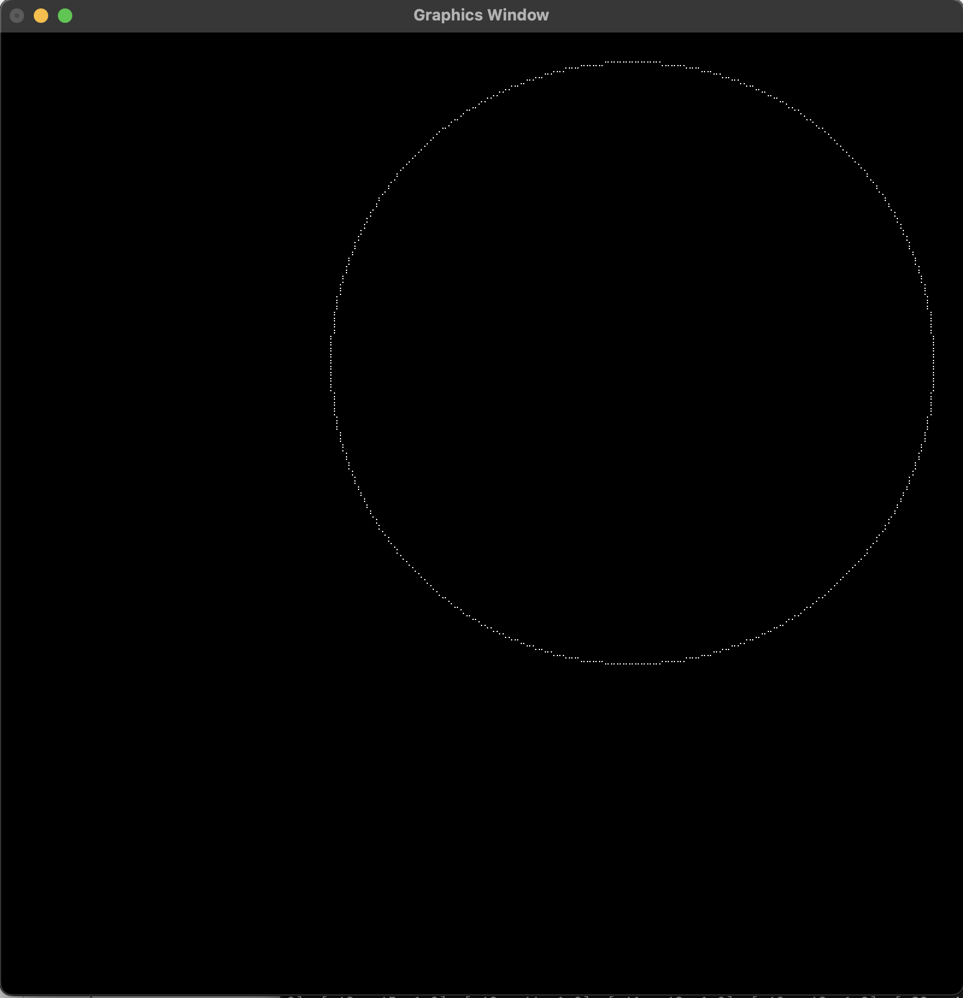***fig 2.3.1.1: Circle at Center (50,50) with Radius 100*

**2.3.2 Circle with Radius 100 and Center at (0, 0)**

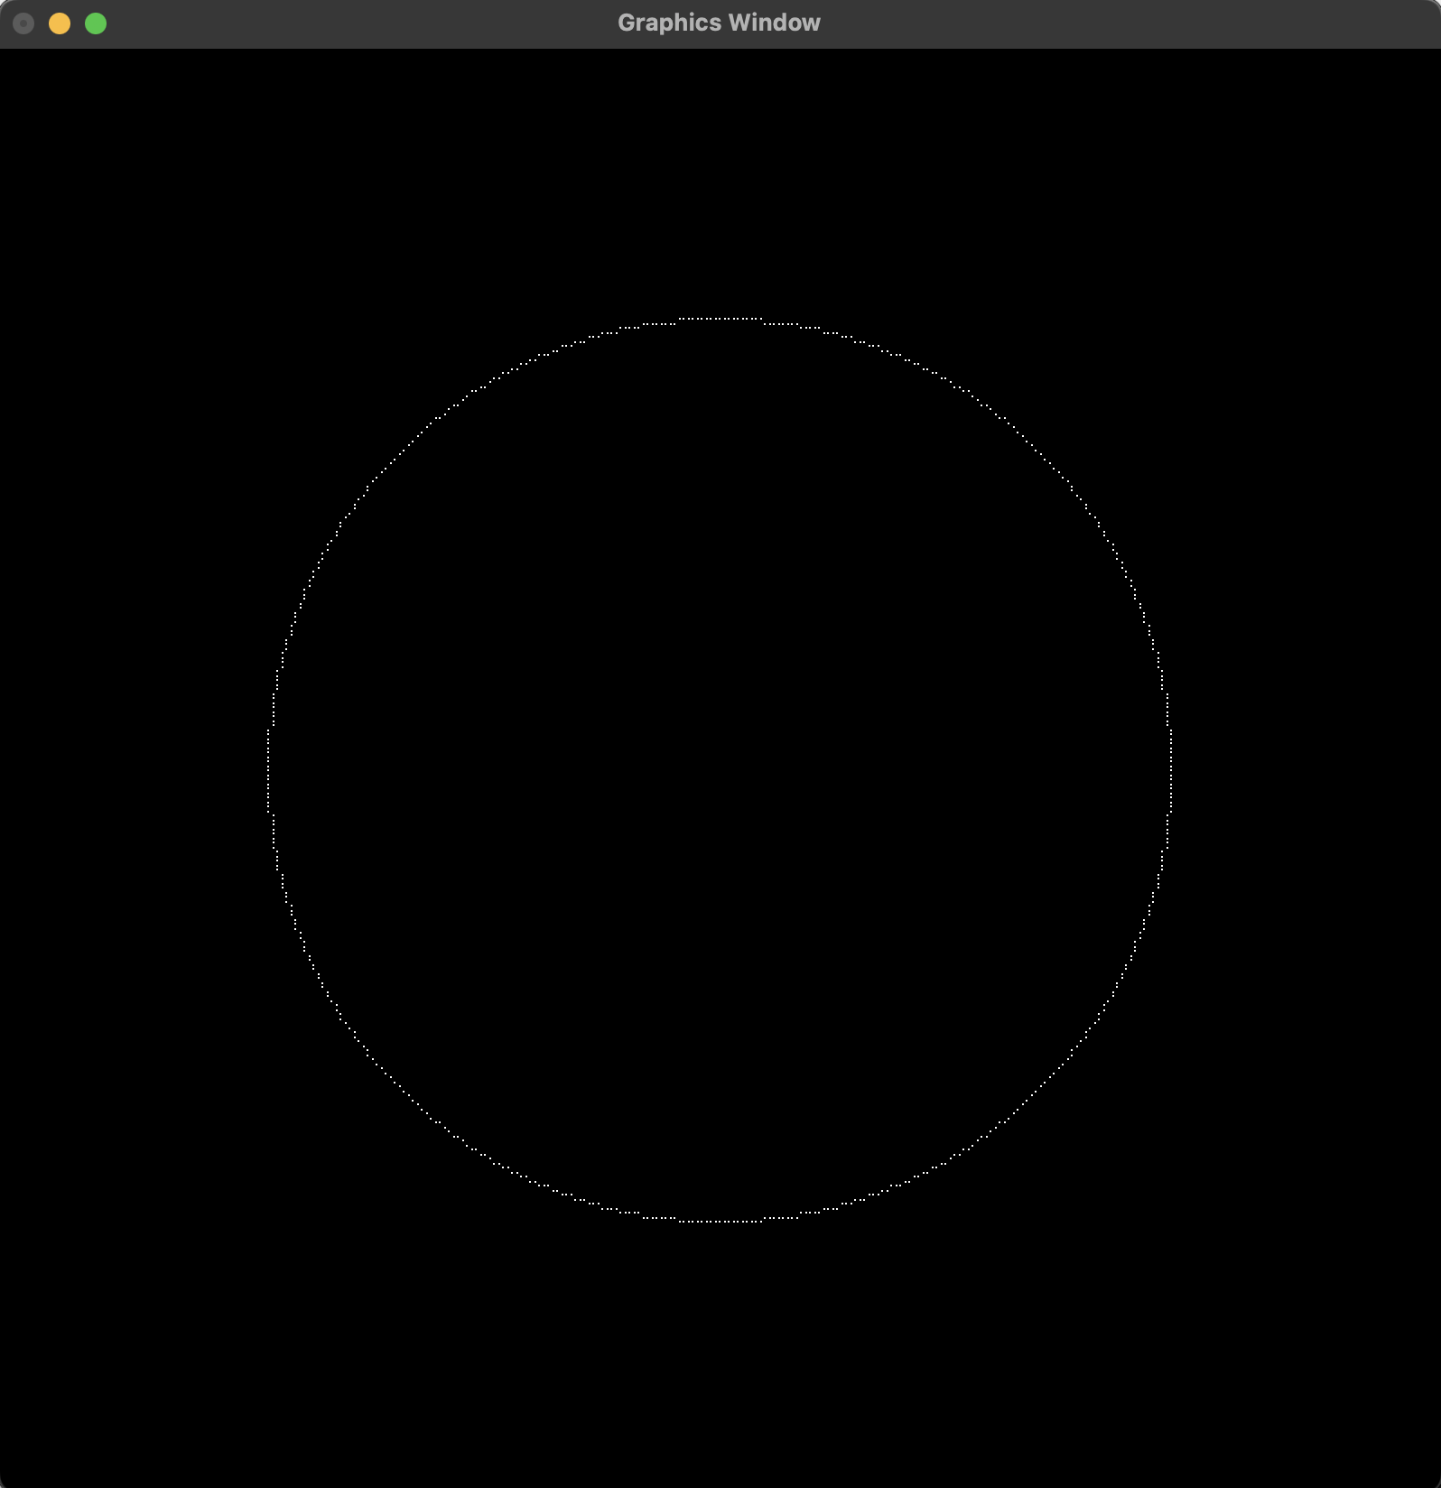

*fig 2.3.2.1: Circle at Center (0,0) with Radius 100*

# Chapter 3: Mid-Point Ellipse Drawing Algorithm

## 3.1 Algorithm

The algorithm used to generate the data points based on the Center, Major Radius and the Minor Radius of an Ellipse through the use of Mid-Point Ellipse Drawing Algorithm is as follows:

1. Take Center (x, y) and Major Radius rx and Minor Radius ry of the Ellipse as inputs.
2. We Start with the Region 1 of Ellipse: | Slope | < 1
3. Set xValue to 0 and yValue to ry.
4. Set Initial Decision Parameter as: P1k = (ry * ry) + (0.25 * rx * rx) – (rx * rx * ry)
5. Compute delX and delY as:
   1. delX = 2 * ry * ry * xValue
   2. delY = 2 * rx * rx * yValue
6. Store (xValue, yValue)
7. Update xValue = xValue + 1
8. Perform the following test:
   1. If P1k < 0 :
      1. Update delX = delX + 2 * ry * ry
      2. Update P1k = P1k + delX + ry * ry
   2. Else :
      1. Update yValue = yValue – 1
      2. Update delX = delX + 2 * rx * rx
      3. Upate delY = delY – 2 * rx * rx
      4. Update P1k = P1k + delX – delY + ry * ry
9. Repeat Step 6 onwards while delX < delY
10. Now we are at the Start of Region 2 of Ellipse
11. Compute P2k as:

P2k = ry * ry * (xValue + 0.5) * (xValue + 0.5) + rx * rx * (yValue -1) * (yValue -1)

1. Store (xValue, yValue)
2. Update yValue = yValue - 1
3. Perform the following test
   1. If P2k < 0 :
      1. Update xValue = xValue + 1
      2. Update delX = delX + 2 * ry * ry
      3. Update delY = delY – 2 * rx * rx
      4. Update P2k = P2k + delX – delY = rx * rx
   2. Else :
      1. Update delY = delY = 2 * rx * rx
      2. Update P2k = P2k + rx * rx – delY
4. Repeat Step 12 onwards while yValue >= 0

**Note:** While storing xValue and yValue, other 3 Symmetric Data Points are calculated and stored as well. Moreover, the Center (xc, yc) is added to the respective coordinates of these stored values. So, the 3 Symmetric Points for (xValue, yValue) are: **(-xValue, yValue), (xValue, -yValue), (-xValue, -yValue)**

and, the stored data values are: **(xc + xValue, yc + yValue), (xc - xValue, yc + yValue), (xc + xValue, yc - yValue), (xc - xValue, yc - yValue)**

## 3.2 Source Code

import os

import sys

import ctypes

import numpy as np

import OpenGL.GL as gl

import OpenGL.GLUT as glut

vertexShaderCode = """

attribute vec3 position;

void main(){

gl_Position = vec4(position, 1.0);

}

"""

fragmentShaderCode = """

uniform vec4 vColor;

void main(){

gl_FragColor = vColor;

}

"""

# -- Building Data --

def ellipseDrawing():

data = []

if len(sys.argv) >= 7:

radius = [int(sys.argv[1]), int(sys.argv[2])]

center = [int(sys.argv[3]), int(sys.argv[4])]

resolution = [int(sys.argv[5]), int(sys.argv[6])]

rX, rY = radius

rXSquared = rX ** 2

rYSquared = rY ** 2

xValue = 0

yValue = rY

P1k = rYSquared + (1/4) * (rXSquared) - (rXSquared * rY)

delX = 2 * rYSquared * xValue

delY = 2 * rXSquared * yValue

while (delX < delY):

data.append([xValue, yValue, 1.0])

xValue = xValue + 1

if (P1k < 0):

delX = delX + 2 * rYSquared

P1k = P1k + delX + rYSquared

else:

yValue = yValue - 1

delX = delX + 2 * rYSquared

delY = delY - 2 * rXSquared

P1k = P1k + delX - delY + rYSquared

P2k = rYSquared * (xValue + 1/2) * (xValue + 1/2) + rXSquared * (yValue - 1) * (yValue - 1) - rXSquared*rYSquared

while (yValue >= 0):

data.append([xValue, yValue, 1.0])

yValue = yValue - 1

if P2k < 0:

xValue = xValue + 1

delX = delX + (2 * rYSquared)

delY = delY - (2 * rXSquared)

P2k = P2k + delX - delY + rXSquared

else:

delY = delY - 2 * rXSquared

P2k = P2k + rXSquared - delY

data = generateOtherPoints(data, center)

else:

raise Exception("Arguments do not match. Correctly Enter Parameters in format : [ major radius X, minor radius Y, center X, center Y, resoultion X and resoultion Y]")

return data, resolution

def generateOtherPoints(data, center):

ellipsePoints = []

for point in data:

ellipsePoints.append([point[0] + center[0], point[1] + center[1], point[2]])

ellipsePoints.append([-point[0] + center[0], point[1] + center[1], point[2]])

ellipsePoints.append([point[0] + center[0], -point[1] + center[1], point[2]])

ellipsePoints.append([-point[0] + center[0], -point[1] + center[1], point[2]])

return ellipsePoints

def tonormalized(coordinates, resolution):

for coordinate in (coordinates):

coordinate[0] = coordinate[0] * 2 / (resolution[0])

coordinate[1] = coordinate[1] * 2 / (resolution[1])

return np.array(coordinates, dtype = np.float32)

# function to request and compiler shader slots from GPU

def createShader(source, type):

# request shader

shader = gl.glCreateShader(type)

# set shader source using the code

gl.glShaderSource(shader, source)

gl.glCompileShader(shader)

if not gl.glGetShaderiv(shader, gl.GL_COMPILE_STATUS):

error = gl.glGetShaderInfoLog(shader).decode()

print(error)

raise RuntimeError(f"{source} shader compilation error")

return shader

# func to build and activate program

def createProgram(vertex, fragment):

program = gl.glCreateProgram()

# attach shader objects to the program

gl.glAttachShader(program, vertex)

gl.glAttachShader(program, fragment)

gl.glLinkProgram(program)

if not gl.glGetProgramiv(program, gl.GL_LINK_STATUS):

print(gl.glGetProgramInfoLog(program))

raise RuntimeError('Linking error')

# Get rid of shaders (no more needed)

gl.glDetachShader(program, vertex)

gl.glDetachShader(program, fragment)

return program

# initialization function

def initialize():

global program

global data

gl.glClear(gl.GL_COLOR_BUFFER_BIT)

gl.glClearColor(0.0, 0.0, 0.0, 0.0)

gl.glLoadIdentity()

program = createProgram(

createShader(vertexShaderCode, gl.GL_VERTEX_SHADER),

createShader(fragmentShaderCode, gl.GL_FRAGMENT_SHADER),

)

# make program the default program

gl.glUseProgram(program)

buffer = gl.glGenBuffers(1)

# make these buffer the default one

gl.glBindBuffer(gl.GL_ARRAY_BUFFER, buffer)

# bind the position attribute

stride = data.strides[0]

offset = ctypes.c_void_p(0)

loc = gl.glGetAttribLocation(program, "position")

gl.glEnableVertexAttribArray(loc)

gl.glBindBuffer(gl.GL_ARRAY_BUFFER, buffer)

gl.glVertexAttribPointer(loc, 3, gl.GL_FLOAT, False, stride, offset)

loc = gl.glGetUniformLocation(program, "vColor")

gl.glUniform4fv(loc, 1, [1.0,1.0,1.0,1.0])

# Upload data

gl.glBufferData(gl.GL_ARRAY_BUFFER, data.nbytes, data, gl.GL_DYNAMIC_DRAW)

def display():

gl.glClear(gl.GL_COLOR_BUFFER_BIT)

gl.glDrawArrays(gl.GL_POINTS, 0, data.shape[0])

glut.glutSwapBuffers()

def reshape(width,height):

gl.glViewport(0, 0, width, height)

def keyboard( key, x, y):

if key == b'\x1b':

os._exit(1)

# GLUT init

glut.glutInit()

glut.glutInitDisplayMode(glut.GLUT_DOUBLE | glut.GLUT_RGBA)

glut.glutCreateWindow('Graphics Window')

glut.glutReshapeWindow(800,800)

glut.glutReshapeFunc(reshape)

data, resolution = ellipseDrawing()

data = tonormalized(data, resolution)

initialize()

glut.glutDisplayFunc(display)

glut.glutPostRedisplay()

glut.glutKeyboardFunc(keyboard)

# enter the mainloop

glut.glutMainLoop()

## 3.3 Outputs

The program takes in the major radius, minor radius, center and resolution of the screen for which these data are for using the command line arguments. For example: the command python ellipsedrawing.py 100 50 0 0 320 320 is used to initialize the Major Radius (Rx) as 100 units, Minor Radius (Ry) as 50 units Center as (0, 0) and the Screen Resolution as (320, 320).

**3.3.1 Ellipse with Major Radius 100, Minor Radius 50, and Center at (0, 0)**

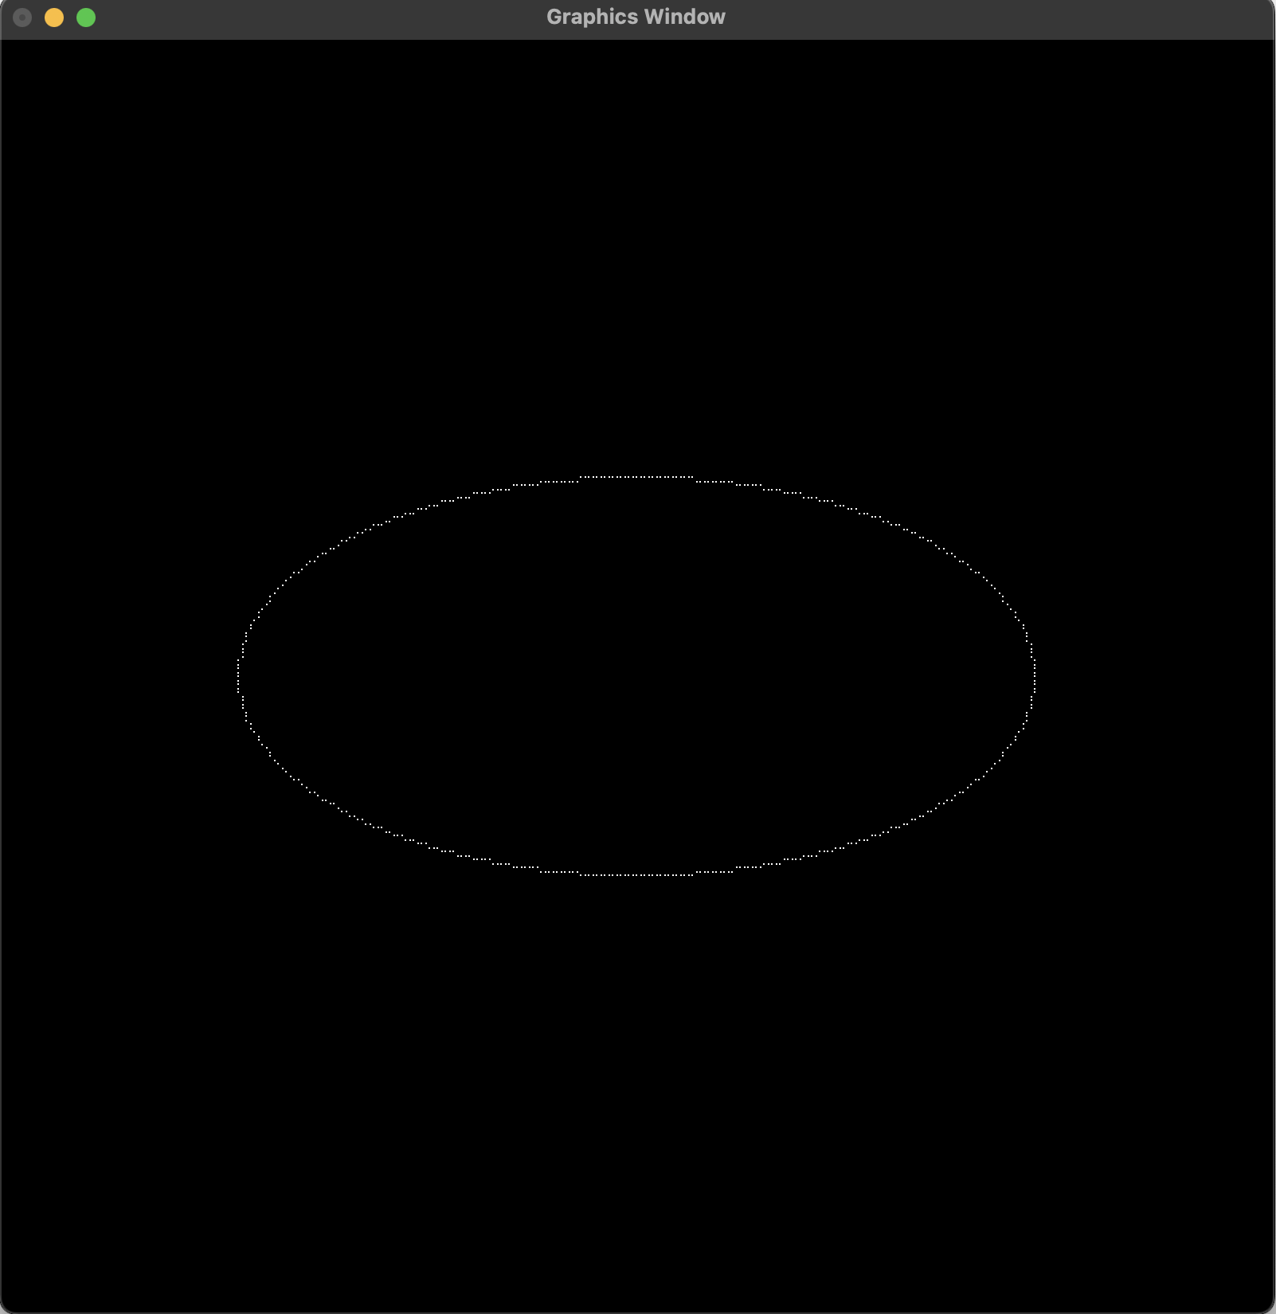*fig 3.3.1.1: Ellipse at Center (0,0) with Major Radius 100, Minor Radius 50*

**3.3.2 Ellipse with Major Radius 100, Minor Radius 50, and Center at (25, 25)**

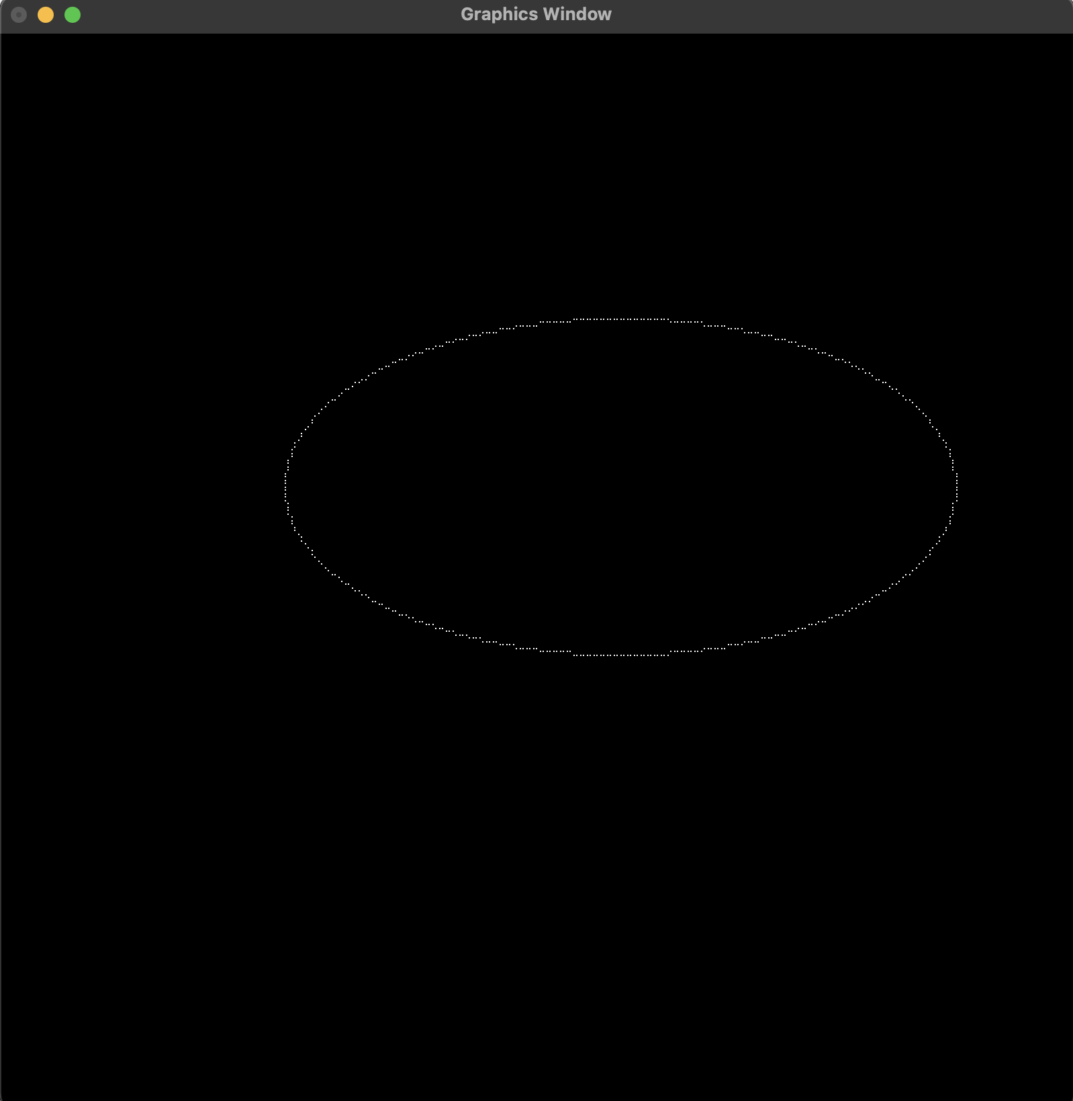

*fig 3.3.2.1: Ellipse at Center (25,25) with Major Radius 100, Minor Radius 50*

**3.3.3 Ellipse with Major Radius 50, Minor Radius 100, and Center at (0, 0)**

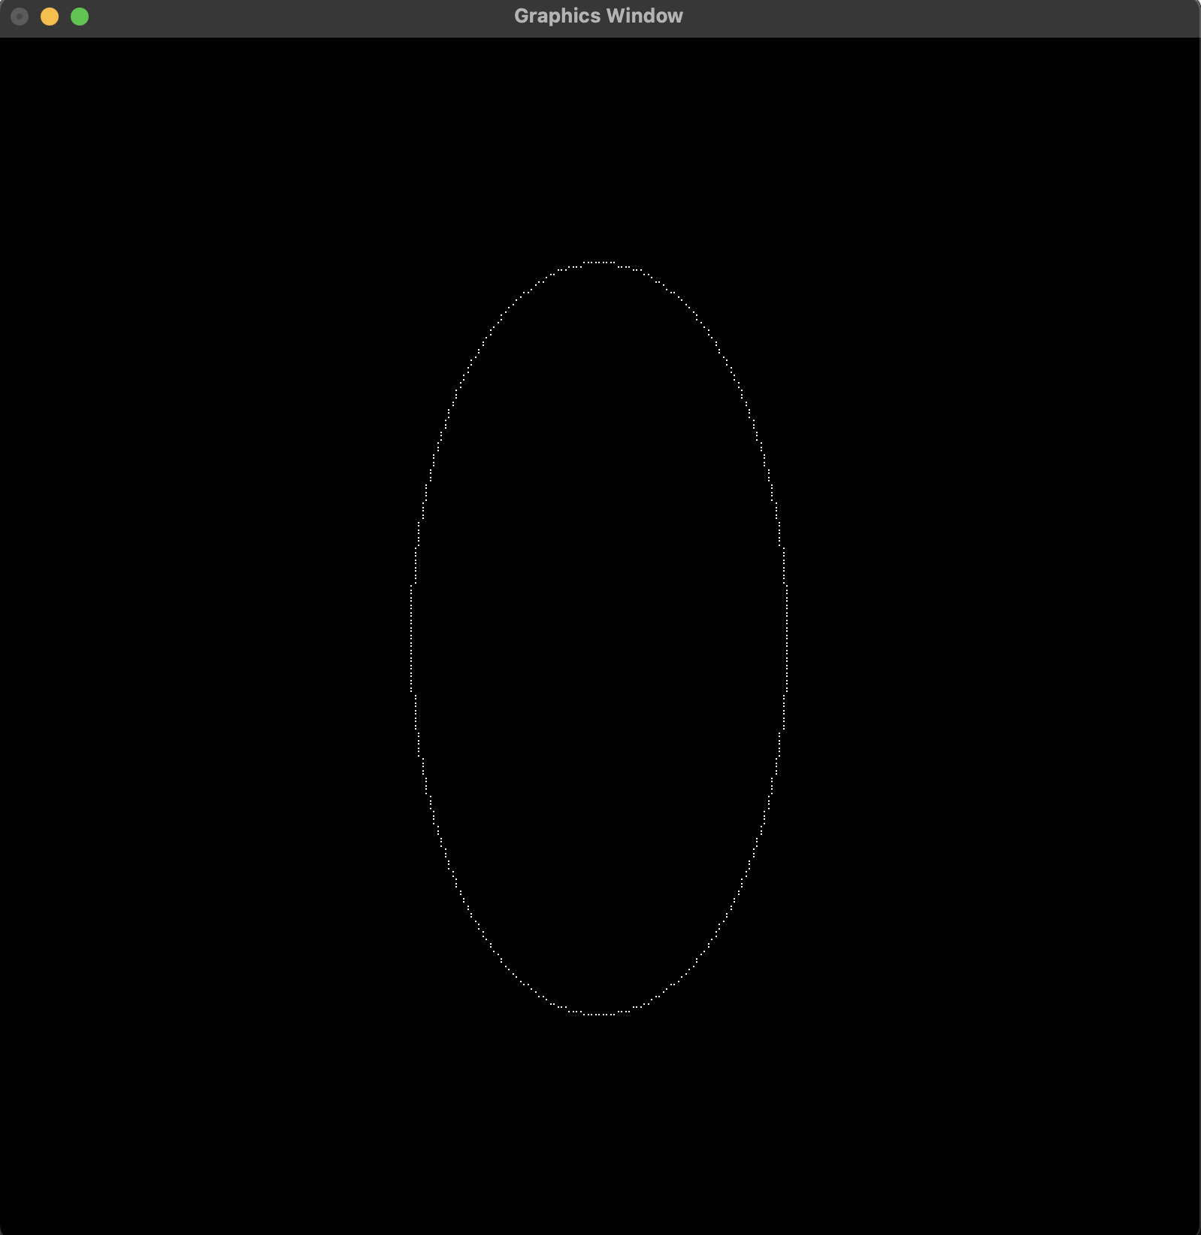*fig 3.3.3.1: Ellipse at Center (0,0) with Major Radius 50, Minor Radius 100*

**3.3.4 Ellipse with Major Radius 50, Minor Radius 100, and Center at (25, 25)**

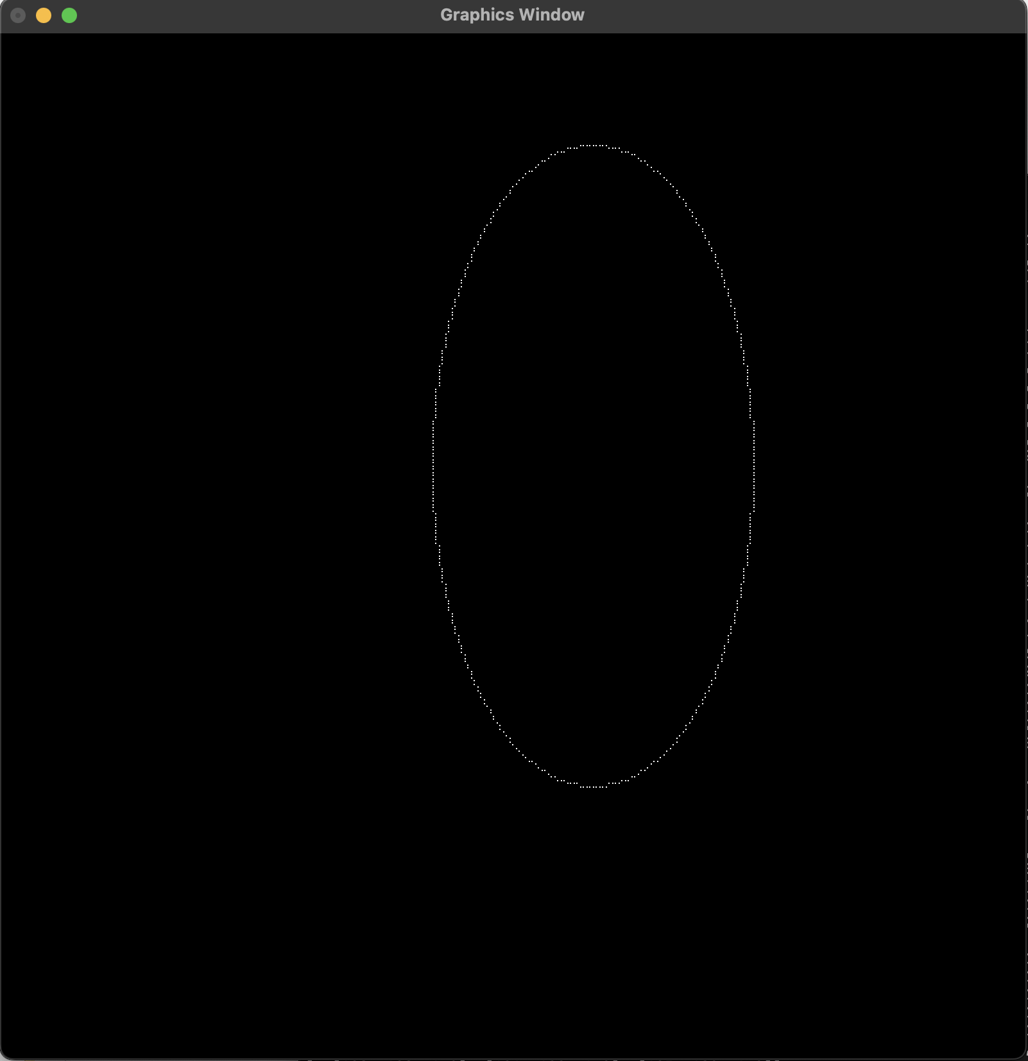

*fig 3.3.4.1: Ellipse at Center (25,25) with Major Radius 50, Minor Radius 100*

# Chapter 5: Conclusion

Through this Lab Work, I was able to study the details of Mid-Point drawing algorithm in drawing a Circle and an Ellipse whilst also recognizing the need to identify and carefully pick between the given pixel choices in order to draw a simple connected curved line segment to properly depict the curvature of these shapes. The written programs use the gl.GL_POINTS primitive supported by OpenGL to demonstrate the creation of an approximately correct line segment on the graphical media instead of the gl.GL_LINES primitive. This is done so to correctly portray the usage of the Mid-Point algorithm as it focuses on creation of shapes through illumination of individual pixels, or in our case individual points. So, using the gl.GL_LINES to draw a curved line segments itself would defeat the purpose of implementing the given algorithm.

Moreover, as seen in the outputs if denser points were to be identified by increasing the resolution of the display during the normalization phase we would observe circle and ellipses that appear to be joint with no gaps in-between the plotted points. However, this was not pursued for this lab work as its main purpose was to visualize that drawing a circle or ellipse using the Mid-Point algorithm is nothing but plotting a set of closely identified points such that upon introduction of denser points it appears to take the shape of either a circle or an ellipse.